**PERTH MODERN SCHOOL**



**YR11 MATHEMATICS SPECIALIST – 2019**

**TEST 2 – Counting Techniques & Vectors**



**NAME: _____________________________________ DATE:_______________**



**Teacher’s Name______________________________**

To achieve full marks working and reasoning should be shown.

**This is a *Calculator Assumed Assessment – 45 minutes / 40 marks***

This section has been intentionally left blank

Q1) Evaluate the following:

1. 10C8 + 10C9 (2 marks)



1. If 20Cr-8 = 20Cr, evaluate the value of *r.* (2 marks)



Q2) Mrs Carter is organising the students for upcoming mathematics competitions for Perth Modern School’s students. Perth Modern School has students from Year 7 up to Year 12, and every student is in 1 of the 4 school houses.

1. How many students would have to be included to have ensure at least one house has 2 students competing? (1 mark)



1. How many students would have to be included to ensure that at least one year level has four students competing. (2 marks)

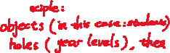

Q3) Relative to the origin , the points , and have position vectors , and respectively.

(a) Determine in Cartesian form

(i) the vector . (1 mark)



(ii) a vector , parallel to and of magnitude . (2 marks)

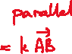

(b) If determine the values of the constants and . (2 marks)

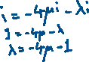

Q4) The following is an **extract** from Pascal’s triangle

|  |  |  |  |  |  |  |
| --- | --- | --- | --- | --- | --- | --- |
| 3 003 | |  | | 1 001 | |  |
|  | 5 005 | | 3 003 | | 1 365 | |
|  | |  | |  | |  |
|  | 19 448 | | 12 376 | |  | |



State the value of each pronumeral: (3 marks)



a=



b=



c=



Q5) Mr Strain is creating a Maths Specialist Exam which has two sections, Section A (Calculator Free) and Section B (Calculator Assumed). He has a library of 10 Calculator Free questions and 12 questions Calculator assumed questions.

Determine the number of different **combinations** of questions the exam could be if the exam was:

(Noting order of question does not matter)

(a) 2 questions in Section A and 5 questions in Section B. (2 marks)



(b) only a single section (either Calculator Assumed or Calculator Free) comprised of 5 questions. (2 marks)



(c) 6 questions, with at least one question from each section. (2 marks)



Q6)

(a) If , and determine

(i) the angle between the directions of and , to the nearest tenth of a degree.

(2 marks)



(ii) the scalar projection of on . (2 marks)



(b) The vector has a magnitude of and is perpendicular to the vector . Determine the values of the constants a and b, where . (4 marks)

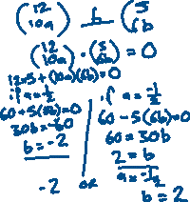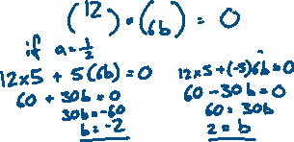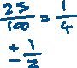

Q7

Mr Gannon has a boat that has an initial position vector of 3 m with respect to a safety marker post. He throttles the motors so the boat moves with a constant velocity of 2m/s.

1. State the position vector after 3 seconds (1 mark)



1. What is the distance between boat the marker post after 7 seconds (2 mark)



1. How many seconds will pass before the boat is 40 metres from the marker post?

(3 marks)

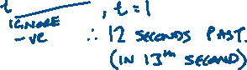

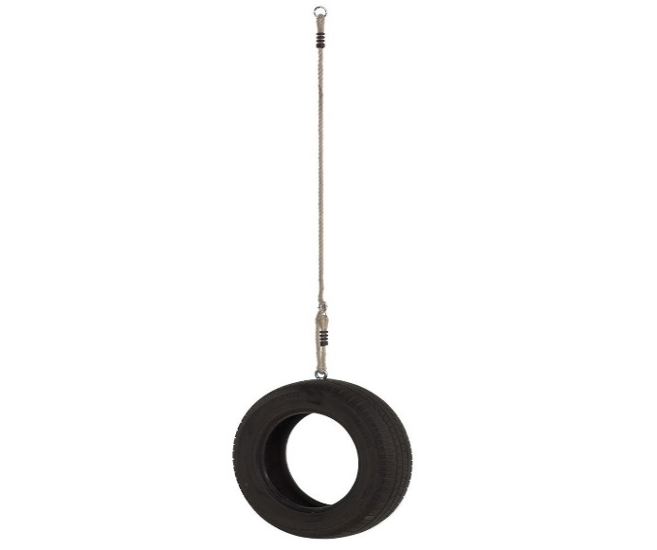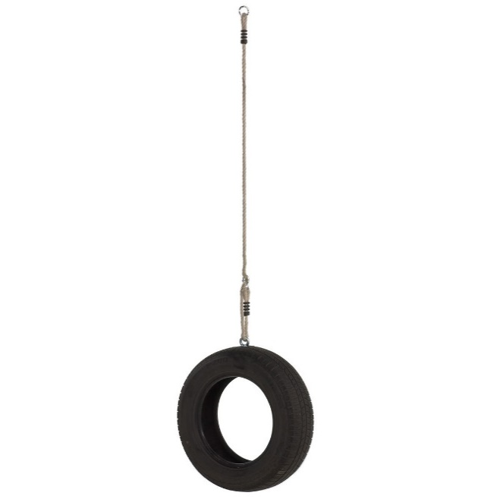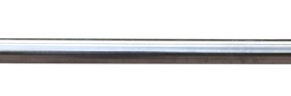

Q8



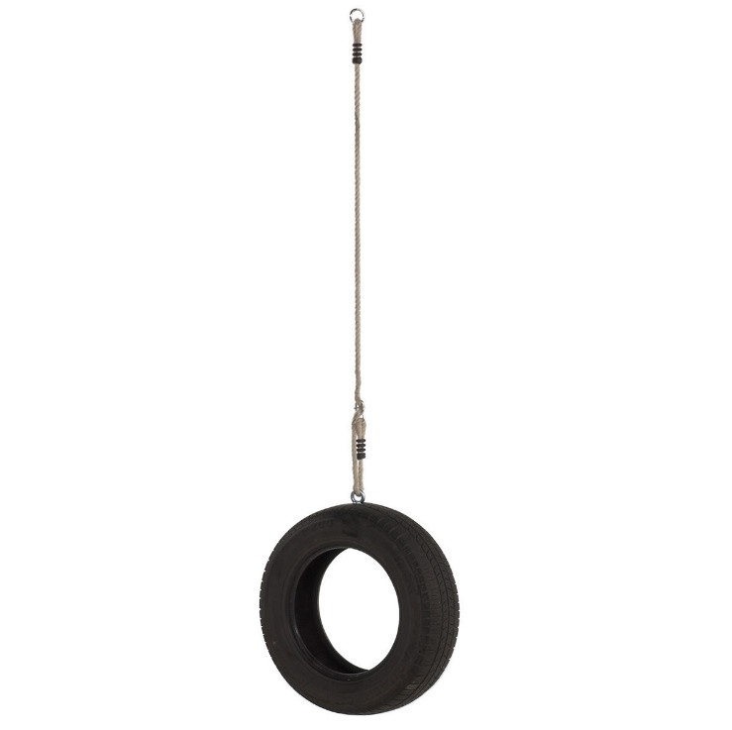

*\*Image for illustrative purposes. Not to scale.*

Dr Pearce is building a tyre swing for his backyard. In order to ensure safety, he has attached 2 ropes to the swing as shown above. The ropes are 4m and 5m in length respectively. The ropes are attached 6 m apart on a horizontal beam.

When in use, the total downward force on the swing will be 980 N.

State the magnitude of force (i.e. tension) on each rope when the swing is being used.

(5 marks)

